Southern Hemisphere MSE Collaboration Workshop: Summary Report

Background
In December 2008, Cathy Dichmont and David Smith (CSIRO, Australia), Doug Butterworth (University of Cape Town, South Africa) and Nokome Bentley (Trophia, New Zealand) met at the “Managing Data-Poor Fisheries Workshop” in Berkeley, California. They discussed the potential benefits of collaboration among the three countries on Management Strategy Evaluation (MSE). To progress this idea further, a workshop was held at CSIRO Hobart Laboratories, 27-28 October 2009. This report provides a brief summary of the workshop in terms of common needs and plans for future collaboration.
The primary objective of the workshop was to scope out future collaboration on MSE in the Southern Hemisphere. Participants came from Australia (CSIRO, the Bureau of Resource Statistics (BRS), Queensland DEEDI, FRDC and AFMA), New Zealand, South Africa and the Secretariat of the Pacific Community (SPC) (see Appendix A). Presentations were given summarising and highlighting MSE work done in each country but most of the workshop time was left open for discussion (see Appendix B).
Discussions focused on developing a generalised MSE framework so as to avoid re-invention, and reduce the costs and time associated with developing and applying management procedures (aka harvest control rules or harvest strategies) to specific fisheries. This is particularly relevant as there is an increasing demand for tested management procedures to be applied to data poor fisheries where both information and the amount of funding are limited.
It was clear from the workshop that Australia (Aus), New Zealand (NZ) and South Africa (SA) share a great deal in terms of past experiences, as well as future needs and aspirations for MSE. The workshop resulted in a constructive discussion of approaches and methods, as well as a pathway to future collaboration. This collaboration includes developing a joint project proposal, primarily between Australia and New Zealand, but also considering the needs of, and seeking to harness the expertise provided by, South Africa where there has been substantial experience with MSE .
A brief note on terminology. In Australia, the approach used to evaluate a “harvest strategy” is labelled “management strategy evaluation (MSE)”. In SA and NZ, the terms “management procedure”, the “management procedure approach” and “management procedure evaluation (MPE)” are used for the same concepts. To reduce confusion, in this document, we use the terms harvest strategies and MSE.

Needs
The workshop provided examples of MSEs used in Australia, New Zealand and South Africa and used these examples to discuss what was needed by way of methodological developments for MSE.

1. Methodological guidelines
The workshop discussed some of the methodological issues involved in conducting a MSE. These issues include “plausibility” (what should the criteria be for including a scenario in set of scenarios against which a harvest strategy is tested), “weighting” (how should alternative scenarios with different levels of plausibility be weighted when results are combined) and “conditioning” (to what extent should scenarios and parameter values be restricted to what can be estimated from the data available for the fishery).
In addition, the workshop discussed the potential for “flexible” harvest strategies, those that rather than providing a single recommendation on total allowable catch (TAC), instead recommend a restricted range of TACs from within which decision makers choose a final TAC. Such harvest strategies may be particularly appropriate in multi-species fisheries. However, the challenge posed by such flexibility is to develop methods by which they can be evaluated through simulation since this is the key strength of the MSE approach.
These issues, and others involved in MSE, often require subtle, subjective decisions to be made by the scientist doing the work. The MSE approach is still relatively new, and although there are many published examples of its use, a detailed set of guidelines for its practical implementation are lacking. Such guidelines could involve a checklist of aspects that should ideally be addressed in all MSEs.
If these guidelines are not developed there is likely to be further divergence in the methods and terminology used in each country. The consistent application of a set of methodological guidelines across countries will enhance our ability to cooperate and obtain maximum leverage from one another’s work.

2. Rapid application of MSE
MSE has generally been done for high value, relatively data-rich, fisheries (e.g. the northern prawn fishery in Australia, the rock lobster fisheries in South Africa and New Zealand). With a few exceptions, the approach has not been applied to low value, data-poor fisheries. The low value of such fisheries does not justify the large expense often associated with MSE. However, such fisheries are often numerous, so that their combined values can be substantial. For example, in New Zealand, around half of the value of quota is in fish stocks for which there is no quantitative stock assessment or MSE (Figure 1). A similar situation probably exists for South Africa and Australia. There is a need for further development of MSE methodology so that the approach can be applied to data-poor fisheries.
Harvest strategies are required for all Australian commonwealth-managed fisheries and there is likely to be similar expectations in the future for other fisheries in Australia, New Zealand, South Africa and the Pacific. However both funding and capacity constraints have restricted the ability to conduct fishery-specific MSEs. Although it is possible to develop harvest strategies without testing them in a MSE, the workshop participants agreed that some form of MSE testing is, at the very least precautionary, and usually, essential. There have been cases where MSEs have shown that what seems like an appropriate harvest strategy does not perform well given the peculiar biological, fishery and monitoring related characteristics of the fishery. Examples were also provided where relatively simple, unconditioned, MSEs can be useful especially when applied to data-poor fisheries.
In summary, there was general consensus that there is a need to be able to apply the MSE approach more widely to fisheries, in particular, to those fisheries that are data-poor and thus for which there is little existing guidance for fisheries management decision making. Unless there is development of MSE methods that make this possible, there is a real risk that this potentially powerful approach to fisheries management will be restricted to relatively few fisheries.
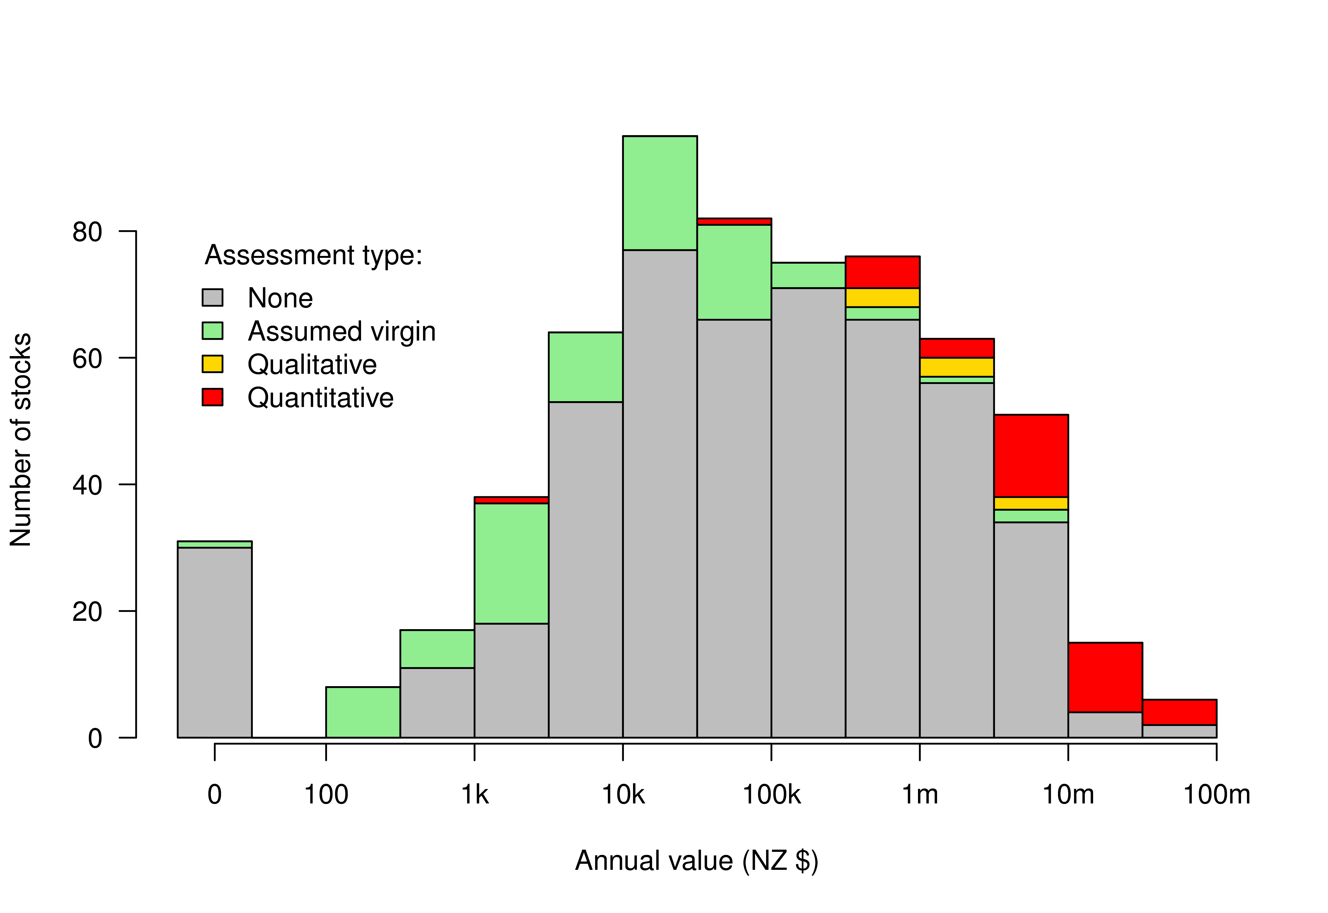
Figure 1. Types of assessments for New Zealand Fishstocks according to annual value (NZ$). Classifications of assessment type are based on unpublished work by Chris Francis and Sophie Mormede, NIWA, with some additions and alterations. “Quantitative” assessments are those that involve fitting stock assessment models to observed data to estimate the status of the stock. “Qualitative” assessments are those that use phrases like “likely to be” or “believed to be” in assessments of stock status based on trends in data such as CPUE. “Assumed virgin” applies to stocks which have little or no history of fishing. “None” means that there is no formal assessment of the status of the stock but that does not necessarily mean that there is no data available for the fishery. Annual value based on total allowable catch (TAC) and port price for 2007-2008. A “Fishstock” is a quota management area for a species and does not necessarily align with the biological stock. There are between 1 and 10 Fishstocks for each species. The total number of Fishstocks represented in the figure is 621. Some Fishstocks are excluded because their assessment status is unknown. The value of some Fishstocks is zero because their TAC is zero. From Bentley and Stokes (in press) Contrasting paradigms for fisheries management decision making: how well do they serve data-poor fisheries? Marine and Coastal Fisheries.

Solutions
The workshop identified possible solutions to the above needs. These are summarised below.

1. Develop methodological guidelines
The workshop proposed to establish an international working group to develop methodological guidelines for MSE. The group would consist of MSE practitioners in each country who would work jointly through email and workshops to develop a set of guidelines for methods and terminology. The working group would also seek input from those working in MSE in the northern hemisphere. It is expected that this group would be mostly funded by individual organisations.

2. Develop a framework for meta-MSE
As described above, there is a need for methods that allow the rapid application of tested harvest strategies to specific fisheries, particularly data-poor fisheries. Developing MSEs case by case is time consuming and often can not be justified relative to the value of the specific fishery. However, the principles of managing fisheries through tested harvest strategies is now seen as standard practice and appropriate given government’s duty of care to the public and industry.
The workshop was presented with one potential solution to this problem which has recently been developed in New Zealand. The approach, dubbed “meta-MSE” (or “meta-MPE” under the NZ naming convention) involves the evaluation of harvest strategies over wide parameter spaces representing a wide variety of fishery scenarios. Meta-MSE uses general knowledge such as the observed relationships between the biological parameters of fish stocks (e.g. from FishBase) as the basis for these wide parameter spaces. To apply the meta-MSE to an individual fishery, rather than building and running a simulation model for that fishery, the meta-evaluation results are filtered (or ‘subsetted’) based on the specific knowledge for the fishery (Figure 2). In essence, the fishery specific MSE becomes a database query on a very large set of evaluation results. This allows for a very rapid initial identification of which harvest strategies might be most appropriate for the fishery at hand. Furthermore, its application is not limited by the degree of fishery specific knowledge, and hence the approach is ideally suited to data-poor fisheries. The approach also allows for an evaluation of research priorities by quantifying the expected benefits from filling gaps in existing knowledge for the fishery. Although this generic approach is unlikely to provide a harvest strategy that is as well customised as one arising from a case specific MSE, it is almost certainly a better alternative than the options of doing nothing or using untested harvest strategies.
The workshop recommended a joint collaborative project on the development of a generalised MSE framework similar to the meta-MSE work developed in NZ. The NZ work has been done by a small project team and is still very much an “initial draft”. Although the NZ project has established the general theoretical approach there is still a significant amount of work to be done to develop meta-MSE further.
The project model proposed by the workshop involves international collaboration in the review and development of the framework combined with national, fishery-specific test cases (Figure 3). This development model attempts to combine the efficiencies of an internationally developed, generic framework with the ‘reality checks’ provided by the national test cases. The choice of national test cases would be guided by national stakeholder committees which would include, amongst others, representative from industry and management agencies (e.g. Australian Fisheries Management Authority, New Zealand Ministry of Fisheries, South African Department of Environmental Affairs and Tourism). The experience gained in the test cases will be synthesised during the review process and potential improvements to the framework will be recommended for the next round of development. We anticipate at least two rounds of testing, review, and development.
Development of the meta-MSE framework will be based on a unified library of programming code. This will include a catalogue of implemented and documented harvest strategies. Making use of a consistent, well designed, programming library has several advantages including (a) allowing harvest strategies that are developed in one country to be added to the catalogue and rapidly tested for fisheries in the other countries, (b) allowing the library to be applied to case-specific MSEs where this is appropriate.
Specific MPE
Meta-MPE
Specific
knowledge
MPE
Select MP
Fishery A
Specific
knowledge
MPE
Select MP
Fishery B
Specific
knowledge
MPE
Select MP
Fishery C
Specific
knowledge
Select MP
Fishery A
Specific
knowledge
Meta-MPE
Select MP
Fishery B
Specific
knowledge
Select MP
Fishery C
General
knowledge
Figure 2: A schematic illustration of how the meta-MPE approach differs from the usual case-specific approach to MPE. On the left, specific MPE is done for each fishery separately. On the right, meta-MPE seeks to harness general knowledge about the dynamics of fish and fisheries to augment more restricted knowledge about data poor stocks. Note that this figure uses the terminology used in the NZ project: MP = management procedure = harvest strategy; MPE = management procedure evaluation = management strategy evaluation (MSE).

Generic – International – Technical Committee

Specific – National – Stakeholder Committees
Review … framework based on success of case specific tests
Develop … framework based on review recommendations
Test … framework by applying it to fisheries in each country
Figure 3: A potential model for the development of a meta-MSE framework. The framework is iteratively developed, tested and reviewed. The development phase is done on a generic level via international collaboration. The testing phase is done by applying the framework to specific fisheries chosen by national stakeholder committees. The review phase seeks to synthesize the lessons from each of the test cases into recommendations for further development of the framework.

Appendix A: Workshop Antendess
- Ann Preece (CSIRO Marine & Atmospheric Research, Hobart, Australia)
- Campbell Davies (CSIRO Marine & Atmospheric Research, Hobart, Australia)
- Carolyn Stewardson (Fisheries Research and Development Corporation, Canberra, Australia)
- Cathy Dichmont (CSIRO Marine & Atmospheric Research, Cleveland, Australia)
- Dale Kolody (CSIRO Marine & Atmospheric Research, Hobart, Australia)
- Dave Alden (Australian Fisheries Management Authority, Canberra, Australia)
- David Smith (CSIRO Marine & Atmospheric Research, Hobart, Australia)
- Doug Butterworth (University of Capetown, South Africa)
- Eva Plaganyi-Lloyd (CSIRO Marine & Atmospheric Research, Cleveland, Australia)
- James Larcombe (Bureau of Rural Sciences, Canberra, Australia)
- Keith Sainsbury (CSIRO Marine & Atmospheric Research, Hobart, Australia)
- Kevin Stokes (Independent Consultant: stokes.net.nz Ltd, New Zealand)
- Malcolm Haddon (CSIRO Marine & Atmospheric Research, Hobart, Australia)
- Marinelle Basson (CSIRO Marine & Atmospheric Research, Hobart, Australia)
- Michael O’Neil (Department of Employment, Economic Development and Innovation, Queensland, Australia)
- Neil Klaer (CSIRO Marine & Atmospheric Research, Hobart, Australia)
- Nokome Bentley (Trophia, New Zealand)
- Sally Wayte (CSIRO Marine & Atmospheric Research, Hobart, Australia)
- Simon Hoyle (SPC - Secretariat of the Pacific Community, New Caledonia)
- Tonya van der Velde (CSIRO Marine & Atmospheric Research, Cleveland, Australia)
The following invitees were unable to attend:
- Alistair Dunn (National Institute of Water & Atmospheric Research, New Zealand)
- Bill de la Mare (CSIRO Marine & Atmospheric Research, Cleveland, Australia)
- Sean Pascoe (CSIRO Marine & Atmospheric Research, Cleveland, Australia)

Appendix B: Workshop Agenda

October 27, 2009 (Tuesday)
09:00 - 09:30 – Introduction (Cathy Dichmont) | Workshop Introduction  - Workshop introduction, participant introductions.  - Aims and expectations.
09:30 - 10:30 – Nokome Bentley | Presentation on Meta MSE work  45 minutes plus 15 minute discussion
10:30 - 11:00 – Coffee break
11:00 - 11:45 – Kevin Stokes | Presentation on New Zealand MSE work  30 minutes plus 15 minute discussion
11:45 - 12:30 – Cathy Dichmont | Presentation on Australian MSE work  30 minutes plus 15 minute discussion
12:30 - 13:15 – Doug Butterworth | Presentation on South African MSE work  30 minutes plus 15 minute discussion
13:15 - 14:00 – Lunch
14:00 - Close – Discussion | What should a collaboration look like?
6:00pm - Drinks & dinner | Venue to be decided

October 28, 2009 (Wednesday)
09:00 – 12:30 – Discussion | What should collaboration look like?
12:30 - 13:30 – Lunch
13:30 – 16:00 – Discussion | The next steps

